**ZephyrDesk**

User Manual

Welcome to the user manual for the support ticket management system built in a model-driven app. This system is designed to manage support tickets for projects and is meant to be used by project managers and developers. There are three stages in this app, with two for project managers and one for developers. In this manual, we will explain how to use the system from start to finish, including how to create a new support ticket, assign tickets to developers, and resolve tickets.

**Project Manager**

1. ZephyrDesk Dashboard: Viewing ticket briefly by the “Status”

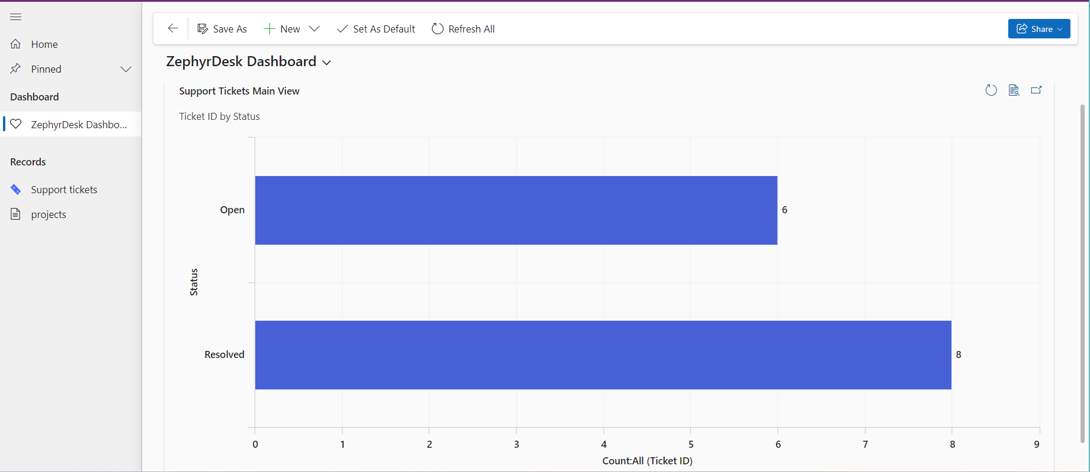

1. Viewing the list of all tickets.

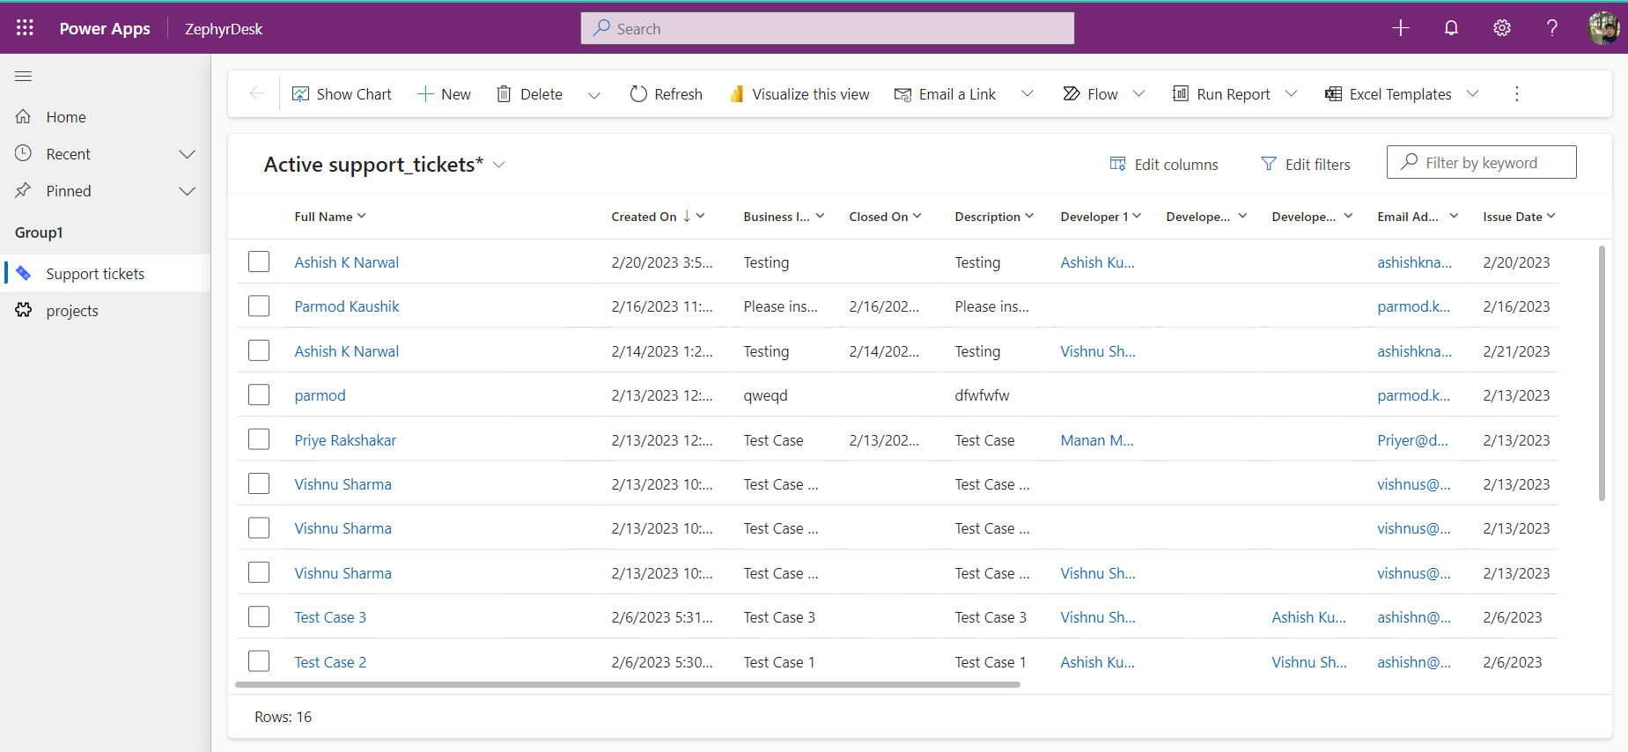

To begin, navigate to the main screen of the support ticket management system. Here, you will see a list of all the support tickets that have been created for the project. The list will display information such as the ticket title, priority level, and date created. To view details about a specific ticket, click on the ticket title.

1. In the first stage, the project manager will assign the following details to a new support ticket:

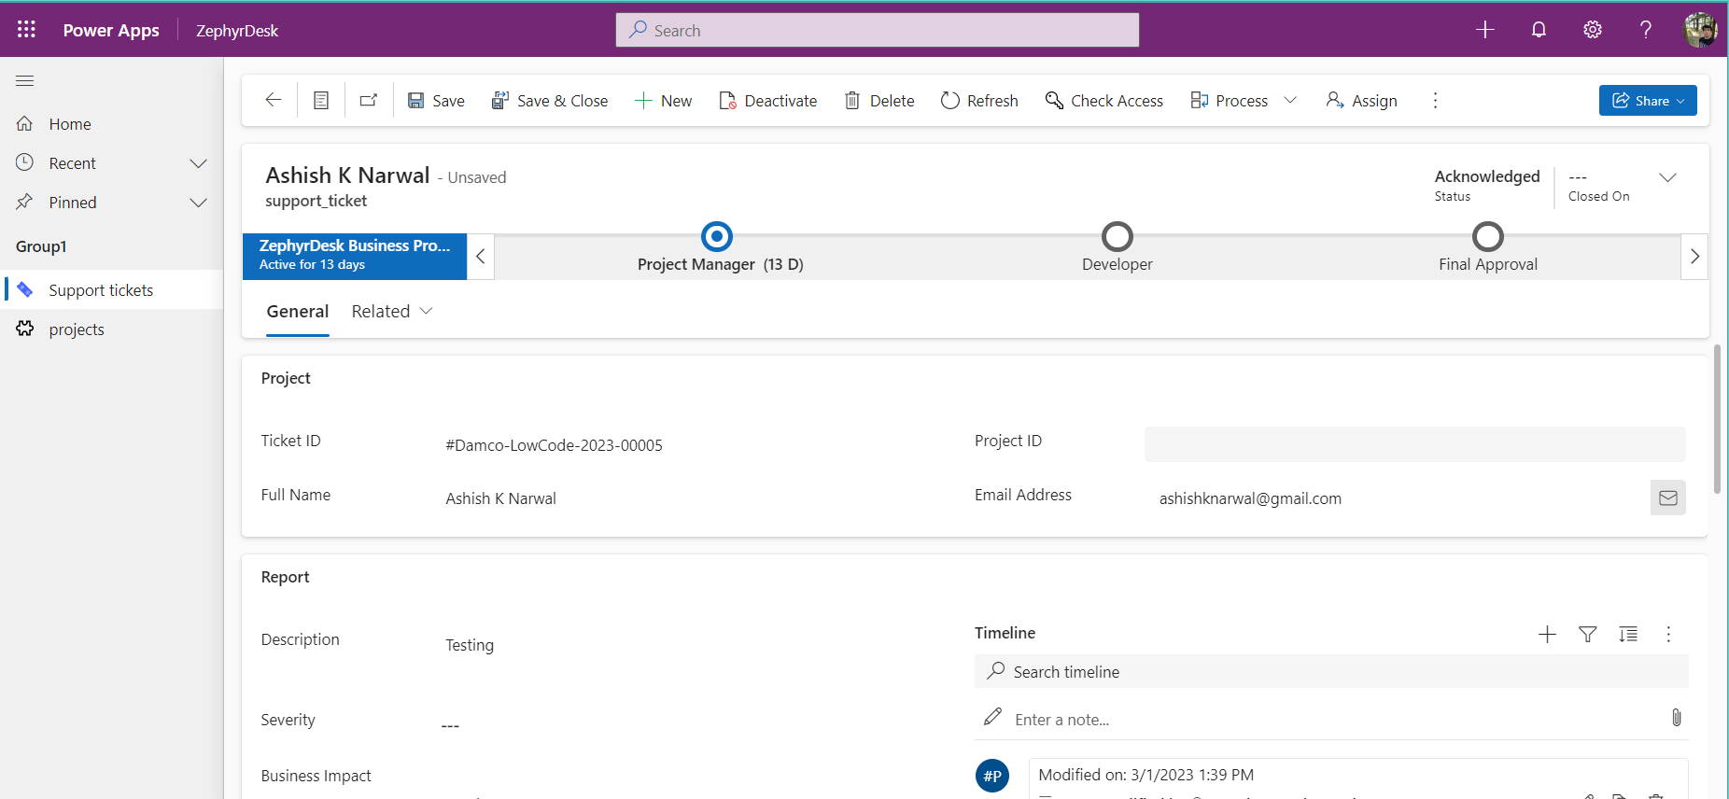

* Priority level: the level of priority of the support ticket, ranging from P1 to P4.

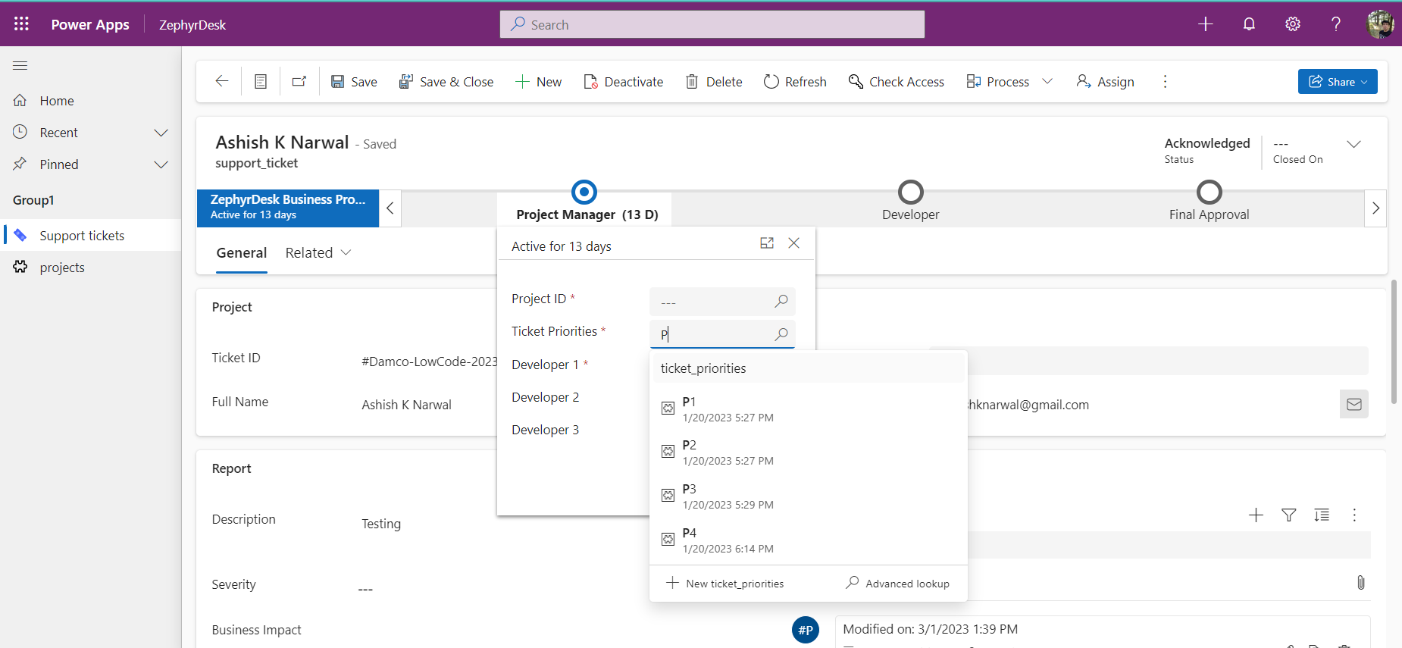

* Developer: the developer/s who will be responsible for resolving the support ticket

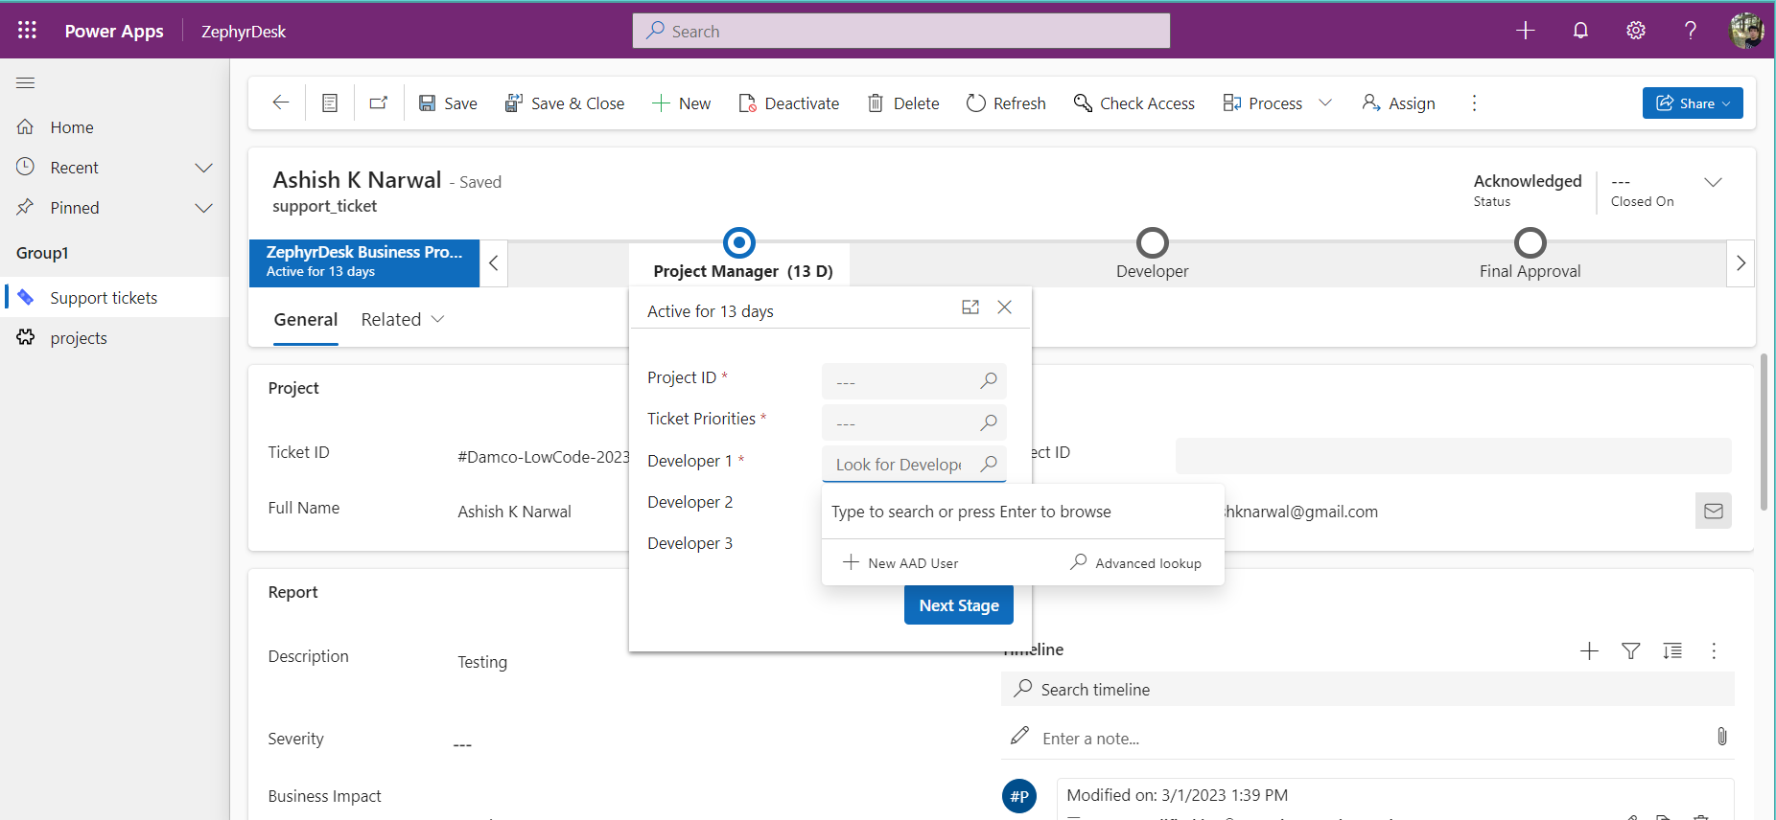

Each support ticket has two status types:

* Ticket status: this is the status of the support ticket as a whole and can be either "Open" or "On-Hold" or “Resolved”.
* Task status: this is the status of the support ticket assigned to the developer and can be either "In-Process" or "Need Escalation" or “Closed”.

By default, the ticket status for new support tickets is "open". Once a developer has been assigned to the ticket by the project manager, the Task status changes to "In-Process". This allows developers to easily see which support tickets they are responsible for, and which ones require their attention. As the developer works on the support ticket, they can update the task status as needed, eventually marking it as "closed" when the issue has been fixed.

Note: It is only after a ticket is closed and the status is changed to “Closed”, it is allowed for reopening.

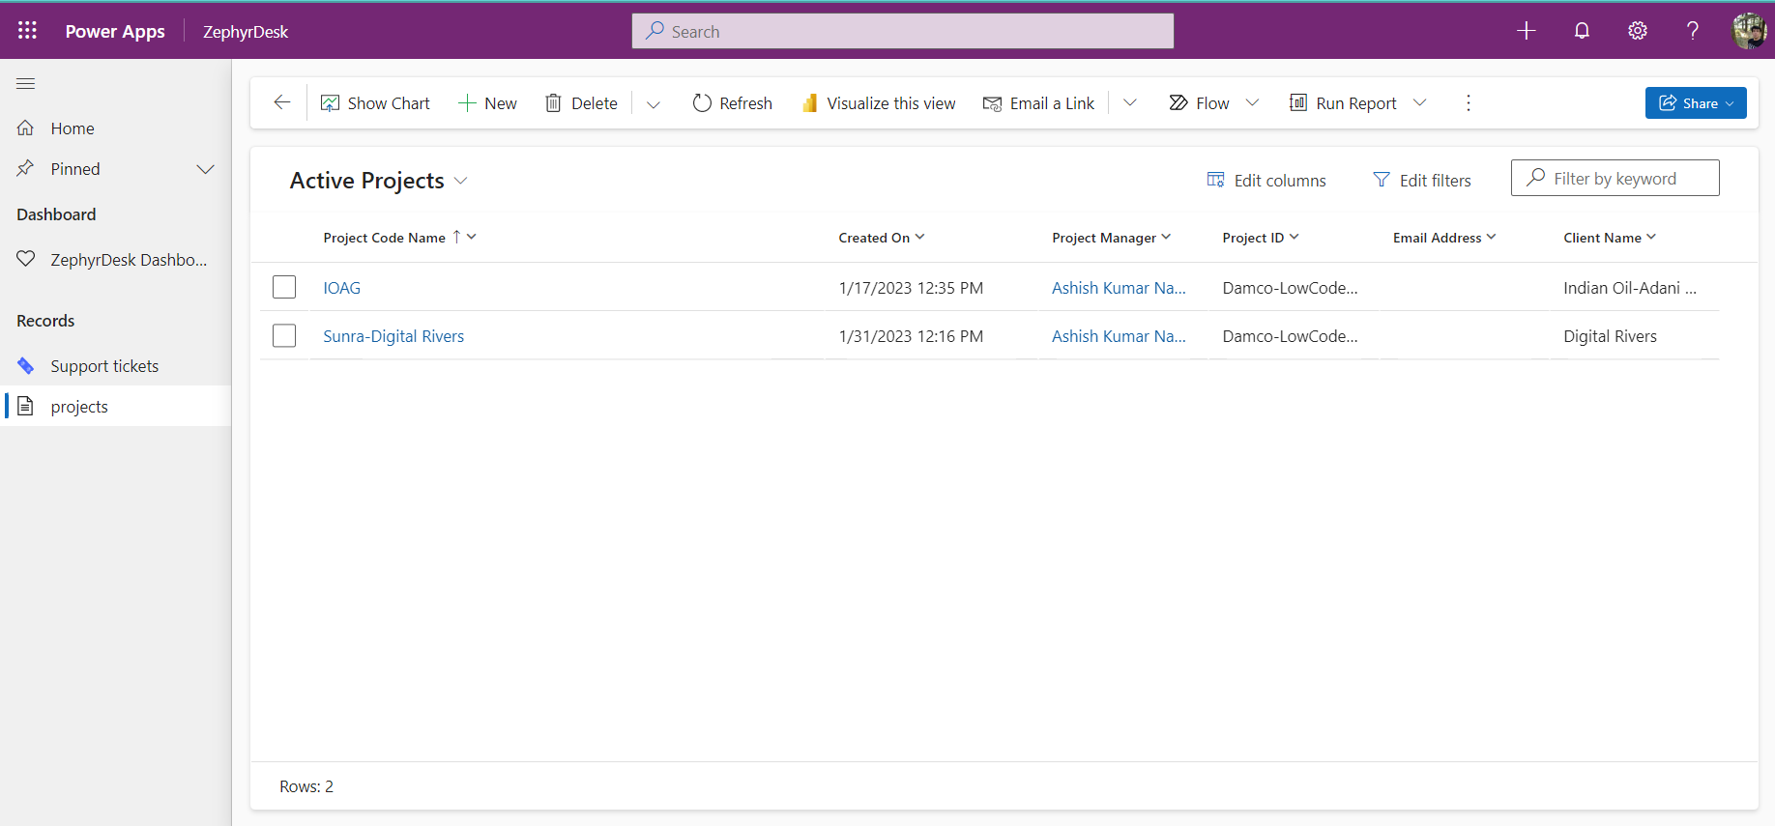

**Developer**

In the developer stage, the developer has two main tasks to complete:

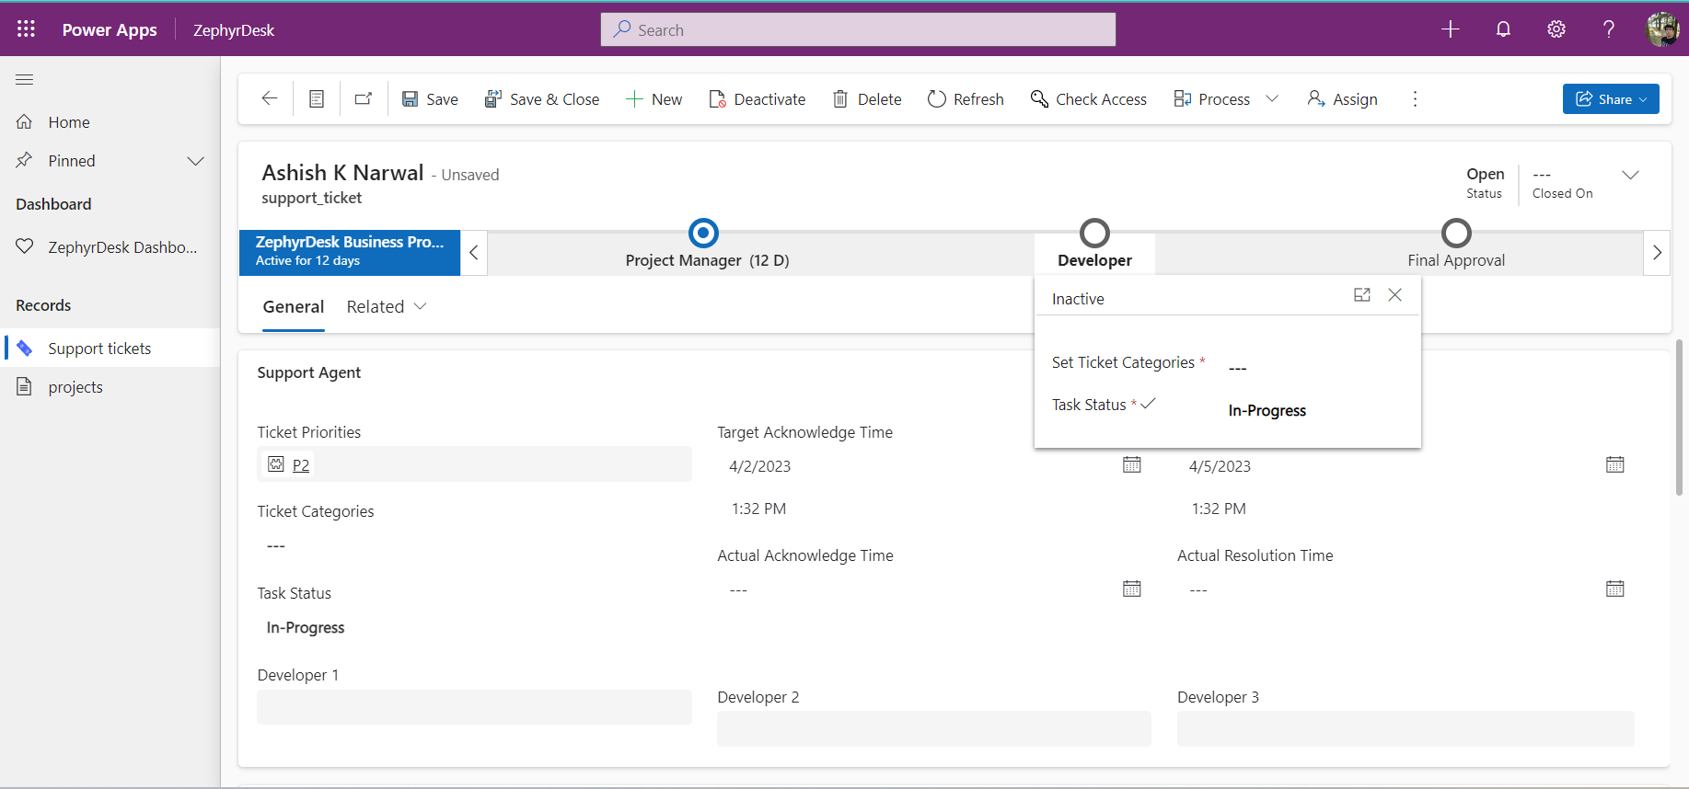

Category: The developer is also responsible for setting the category of the support ticket. This helps to categorize and prioritize support tickets based on the type of issue or request. The available categories may include things like "Bug", "Feature Request", "General Inquiry", and so on. By setting the category appropriately, developers can help ensure that support tickets are assigned to the right team members and are resolved in a timely manner.

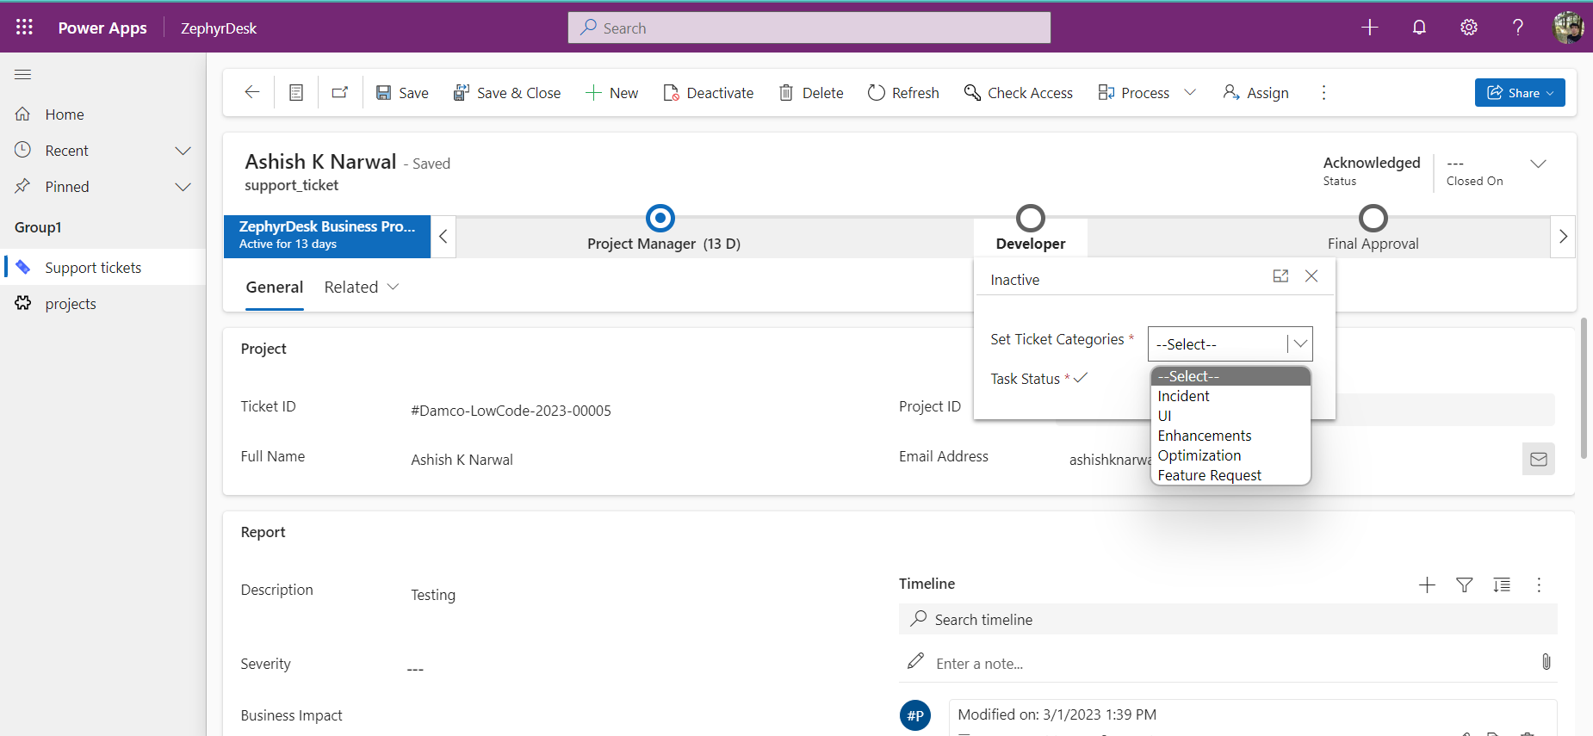

Task status: The developer is responsible for updating the task status of the support ticket as they work on it. The available options are:

* Need Escalation: If the developer requires additional resources or support, they can change the task status to "Need Escalation".
* Closed: Once the work on the support ticket is complete, the developer can change the task status to "Closed". This will trigger a flow that will send an email to the project manager, notifying them that the ticket is ready for review.

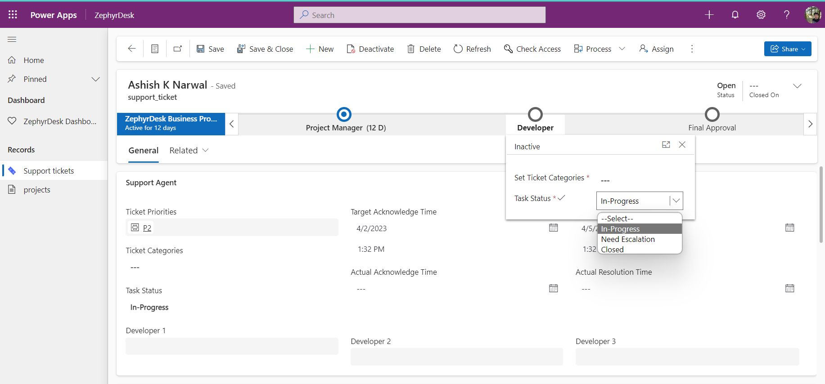

**Project Manager**

1. If more details are required from the client before the developer can continue working on the support ticket, they (Project Managers) can change the task status to "On Hold".
2. In the final approval stage, project managers will review the resolved support tickets and check the work done by the developers. Once they are satisfied that the issue has been resolved, they can change the status of the ticket to "resolved." This will trigger a flow that will automatically send a confirmation email to the client, letting them know that the issue has been resolved. The email will include details about the ticket, including the title, description, and resolution. This automated email helps to ensure that clients are kept informed and up to date on the status of their support tickets and helps to maintain good communication between the project team and the client.

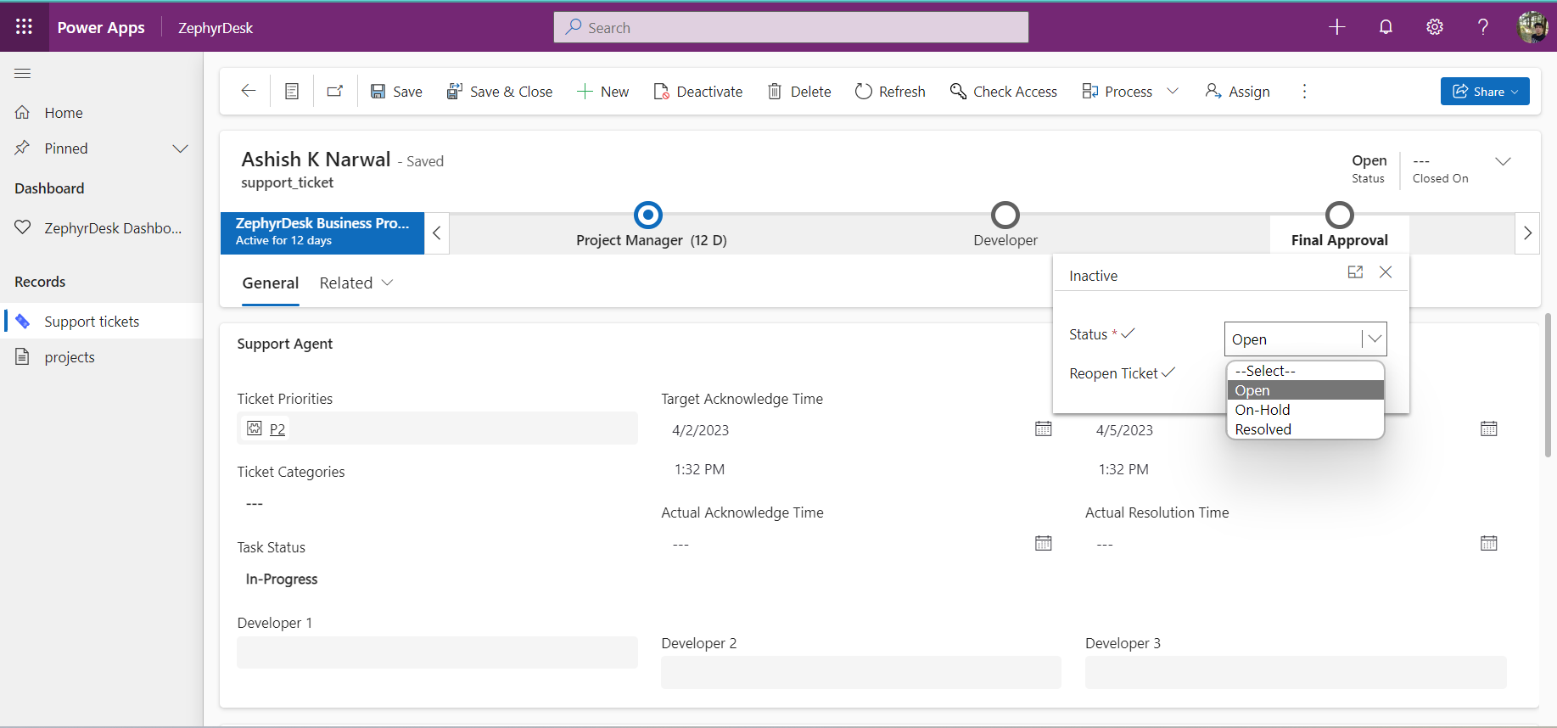

Congratulations, you have now learned how to use the support ticket management system built in a model-driven app. If you have any questions or need further assistance, please contact team ZephyDesk.